Place Your Paper Title Here with Title Capitalization that May Run Multiple Lines
Firstname Q. Lastnameª, Givenname R. S. Surname Jr.^{b}, and Third Author^{s}*
ª Provincial University, Department of Chemical Engineering, City, Province, Country
^{b} State College, Engineering Department, City, State, Country
* Corresponding Author: author.email@someuniversity.ca.
Abstract
Type your abstract text here. Please limit to 250 words. Uses the style PSE_AbstractText. Lorem ipsum dolor sit amet, consectetur adipiscing elit, sed do eiusmod tempor incididunt ut labore et dolore magna aliqua. Ut enim ad minim veniam, quis nostrud exercitation ullamco laboris nisi ut aliquip ex ea commodo consequat. Duis aute irure dolor in reprehenderit in voluptate velit esse cillum dolore eu fugiat nulla pariatur. Excepteur sint occaecat cupidatat non proident, sunt in culpa qui officia deserunt mollit anim id est laborum.
Keywords: Choose an item., Choose an item., Choose an item., Choose an item., Choose an item., additional keywords separated by commas

this is header 1
This is Header 2
Regular text uses the PSE_Text style. Please do not add spaces between paragraphs. Paragraphs will indent automatically and will hyphenate automatically. Do not add extra paragraph spaces between sections.
This is header 3
Use the PSE_Header styles for all headers. When you do this, do not add extra blank paragraph whitespace between text and headers, the spacing will already be set.
This is header 4
Some text that follows header 4.
Figures and Tables in the text
One Column-Width Figures
The standard column width is 8.5 cm in this template. When inserting a single-column figure in the text, insert the figure in its own paragraph, and change the style of that paragraph to PSE_FigureAndCaption. Insert the figure. On the next line, type the figure caption, and make sure that it is also styled as PSE_FigureAndCaption. Place the figure where it best flows with the text.
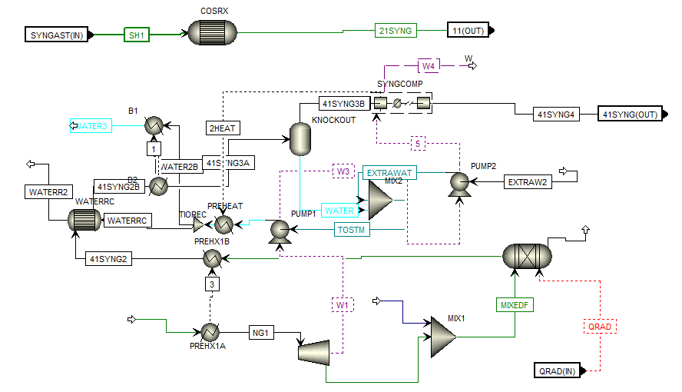
Figure 1. Example 1-column figure with a short caption.
One-Column Tables
Use the Insert | Table feature to insert a table with a single column width, inline in the text. Use PSE_TableCaption for the caption and PSE_TableContent for the table itself. Use the PSE_TableFormat template in the Table Design ribbon to apply standard borders, but feel free to add other rules and lines as needed to best communicate your table. (You will not see PSE_TableFormat in the list of styles, that is found in the Table Design ribbon).

Table 1: Caption for the table. Multi-line table captions will be fully justified. The style is PSE_TableCaption.
Stream | Description | Flow
Feed | A mixture of MeOH, EtOH, & BuOH. | 11.2 kmol/hr
Side Draw | Mostly ethanol | 115.0 kmol/hr
Distillate | Mostly methanol | 21.5 kmol/hr
Bottoms | Mostly butanol | 110 kmol/hr
Two Column (Page-Width) Tables and Figures
The printable page width is 17.5 cm, but images and tables should be limited to 17 cm wide. Use the Insert Text box feature in Microsoft word and use a Simple Text Box (leave the borders around it). Use the same PSE_FigureAndCaption, PSE_TableCaption, and PSE_TableContent styles that you would use for single column tables and figures. Resize the text box appropriately. To snap the box to the top or bottom of the page, click the text box, go to the Shape Format ribbon. In the Position drop down, choose the icon in the upper left to have the text box snap to the upper left portion of the page. Place the text box on whatever page is most convenient to your message. In fact, the example is located on the next page.
How to CITE REFERENCES IN THE TEXT
Text citations should use numbers in square brackets [1] and placed at the end of the phrase that is most appropriate in the context of the sentence, which may or may not be at the end of the sentences. You can cite ranges of papers [1-5] or sets of papers [3,5,8].
Table 1: Composition of captured CO₂ stream for each purification design. Use PSE_TableCaption for the caption and PSE_TableContent for the content. Please use below ruling and header guides if possible.
 | Kinder Morgan Pipeline Spec | Base case | Cryogenic distillation | Oxygen deficient | Catalytic de-oxygenation
CCS Enabled |  | Yes | Yes | Yes | Yes
Meets pipeline Spec? |  | No | Yes | Yes | Yes
H₂O | 690 ppm | 337 ppm | 401 ppm | 337 ppm | 314 ppm
CO₂ | >95% | 95.1% | 99.9% | 97.6% | 98.5%
H₂S | 10-200 ppm | trace | trace | trace | trace
CO | no spec | trace | trace | 1.00% | trace
C_{x}H_{y} | <5% | trace | trace | trace | trace
H₂, N₂, Ar | <4% | 1.34% | 0.44 ppm | 1.37% | 1.4%
O₂ | <10ppm | 3.49% | 9.40 ppm | 9.41 ppm | 8.06 ppm
NO₂ | no spec | 0.28 ppm | 0.31 ppm | 0.12 ppm | 0.27 ppm
N₂O | no spec | 0.01 ppm | 0.01 ppm | 0.01 ppm | 0.01 ppm
SO₂ | no spec | 305 ppm | 338 ppm | 317 ppm | 316 ppm
SO₃ | no spec | 0.72 ppm | 0.80 ppm | 0.47 ppm | 0.72 ppm
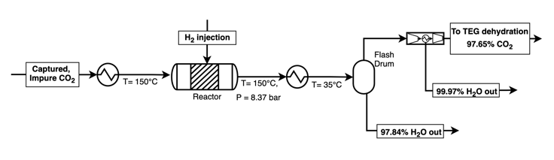
Figure 2: For wide figures and tables, place inside of a text box (you can copy-paste this textbox into your paper to start. If desired, you can put multiple items in one box.
Other Formatting instructions
Equations in the Text
Equations should look like the following. Use the Equation Editor in Microsoft Word (Alt + = or Insert | Equation). Then use PSE_Equation for the style. Add the equation reference numbers in parenthesis after the equation inline, and use tabs until the equation numbers are aligned properly (equation numbers and whitespace should all use PSE_Equation). Do not add additional space above or below equation as that will be handled by the style.
$f\left(x\right)=μ\int_{0}^{∞}{\frac{1}{x}dx}$ (1)
$f\left(x\right)=αβ\int_{0}^{∞}{\frac{1}{x}dx}+y/x$ (2)
You can use LaTeX format or UnicodeMath format if you prefer. Here is an example of a matrix that was made using LaTeX. To add a LaTeX format equation, hit Alt + = or Insert | Equation to add a new equation, and make sure the Conversions is set to LaTeX in the Editor ribbon (you should only need to do this the first time).
$A=\{\begin{matrix}a & b & c \\ d & e & f \\ g & h & j\end{matrix}\}$ (3)
Code
You can use the style PSE_CodeInline to format computer code inline within the text, such as a function name. For code blocks, use PSE_Code as demonstrated below.
for i in range(NPoints):
T.append(600 + (400) * (i/(NPoints-1)))
P.append( 2 + (50) * (i/(NPoints-1)))

random.shuffle(P)
Language and Spelling
We prefer US English. Other forms are acceptable.
Headers, Footers, and Copyright
Do not make any other modification to the headers, footers, margins, or copyright information after the references.
DIGITAL supplementary material
Digital supplementary material (data sheets, data files, additional explanatory text, examples, stream condition tables, simulation files, models, or source code) can be included in your paper by having a header just before the acknowledgments called Digital Supplementary Material. Include a brief description, and hyperlinks to the material. Delete section if not used.
You are encouraged to submit digital supplementary materials to the Living Archive for Process Systems Engineering at http://PSEcommunity.org/LAPSE. You can then refer to your digital materials by using the LAPSE ID in this section. We will hyperlink it to your LAPSE submission automatically.
ACKNOWLEDGEMENTS
Please acknowledge your funders in this section, with grant or funding numbers as appropriate.
References
- Author FN, Suffix AB Jr, Roman BC III, Multiple Surname GV. Title of the paper in sentence case. Abbrev J Title 4:32-42 (2020)
- Inventor FN. Title of the patent in sentence case. US Patent 3,765,134. (2019)
- Author FN, Other SD. Capitalized Title of the Book. Publisher (2021).
- Author FN, Other CA. Title of the section of the book. In: Capitalized Title of the Edited Book. Ed: Editor QC, Other JC. Publisher (2022)
- Webpage author. http://hyper.link/deep/link.html
© 2024 by the authors. Licensed to PSEcommunity.org and PSE Press. This is an open access article under the creative commons CC-BY-SA licensing terms. Credit must be given to creator and adaptations must be shared under the same terms. See https://creativecommons.org/licenses/by-sa/4.0/

